**3D Design Unit Plan**

**Tinker Cad**

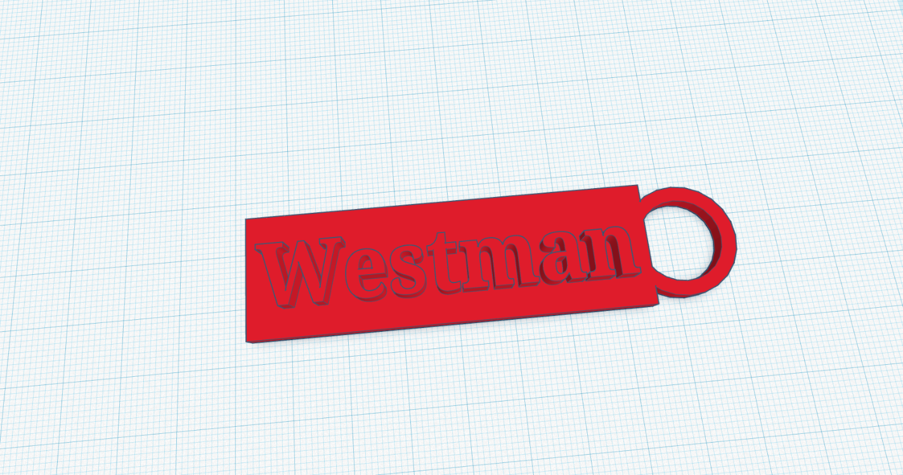

Objective: Concept / Topic to teach:

* Students will learn about the process of creating a Three-dimensional object using an auto cad program like TinkerCAD.
* Students will demonstrate their understanding of 3D Printers.
* Students will define terms related to 3-D design and printing.
* Students will create a simple 3-D project where they will make a luggage tag.
* Students will create an original final project using the skills they have learned to create a Balloon Powered Racecar.

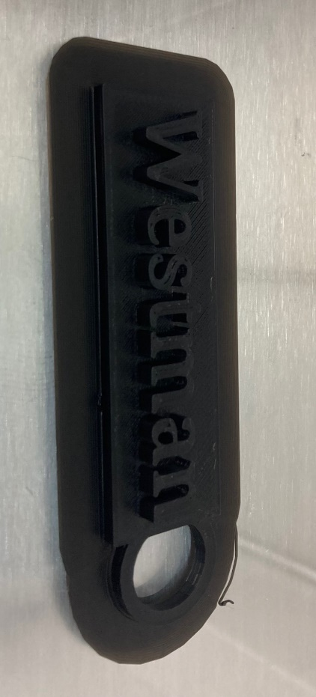

Standards Addresses

Technology Standards (ISTE)

Empowered Learner: (1) Students leverage technology to take an active role in choosing, achieving, and demonstrating competency in their learning goals, informed by the learning sciences. (1a) Students articulate and set personal learning goals, develop strategies leveraging technology to achieve them and reflect on the learning process itself to improve learning outcomes. (1b)Students build networks and customize their learning environments in ways that support the learning process. (1c) Students use technology to seek feedback that informs and improves their practice and to demonstrate their learning in a variety of ways. (1d) Students understand the fundamental concepts of technology operations, demonstrate the ability to choose, use and troubleshoot current technologies and are able to transfer their knowledge to explore emerging technologies.

Digital Citizen: Students recognize the rights, responsibilities and opportunities of living, learning and working in an interconnected digital world, and they act and model in ways that are safe, legal and ethical. (2b) Students engage in positive, safe, legal and ethical behavior when using technology, including social interactions online or when using networked devices.

Knowledge Constructor: Students critically curate a variety of resources using digital tools to construct knowledge, produce creative artifacts and make meaningful learning experiences for themselves and others. (3b) Students evaluate the accuracy, perspective, credibility and relevance of information, media, data or other resources. (3c) Students curate information from digital resources using a variety of tools and methods to create collections of artifacts that demonstrate meaningful connections or conclusions.

Creative Communicator: Students communicate clearly and express themselves creatively for a variety of purposes using the platforms, tools, styles, formats and digital media appropriate to their goals. (6a) Students choose the appropriate platforms and tools for meeting the desired objectives of their creation or communication.(6b) Students create original works or responsibly repurpose or remix digital resources into new creations.(6c) Students communicate complex ideas clearly and effectively by creating or using a variety of digital objects such as visualizations, models or simulations.(6d) Students publish or present content that customizes the message and medium for their intended audiences.

Reading, Writing and Communicating

2. Integrate credible, accurate information into appropriate media and formats to meet an audience’s needs.

1. Write thoughtful, well-developed arguments that support knowledgeable and significant claims, anticipating and addressing the audience’s values and biases.

4. Use a recursive writing process to produce, publish, and update individual or shared writing projects in response to ongoing feedback.

1. Synthesize multiple, authoritative literary and/or informational sources to answer questions or solve problems, producing well-organized and developed research projects that defend information, conclusions, and solutions.

Mathematics – Geometry

HS.G-CO.D. Congruence: Make geometric constructions.

HS.G-SRT.A. Similarity, Right Triangles, and Trigonometry: Understand similarity in terms of similarity transformations.

HS.G-GMD.B. Geometric Measurement and Dimension: Visualize relationships between two-dimensional and three-dimensional objects.

HS.G-MG.A. Modeling with Geometry: Apply geometric concepts in modeling situations.

Visual Art

1. Establish a practice of planning and experimentation to advance concepts and technical skills.

2. 2. Ideate and build works of art and design to demonstrate growth and proficiency in traditional and new art media.

Specific Objectives:

* Design a simple object in the Tinker Cad program that allows students to use features that they will need to do throughout 3D Modeling in a computer program.
* Students will begin the learning process by fooling step-by-step designs that will lead them through the creation of baggage name tags that they can use.
* <https://www.vla.org/assets/Conference_Session_Docs_Slideshows/2017_VLAAnnual/PresenterMaterials/tinkering%20with%20tinkercad%20-%20a%20beginners%20guide%20to%20creating%203d%20printer%20designs%20-%20michael%20hibben.pdf>
* Once the name tag has been completed students will begin an increased level printing project that will have them designing a balloon-powered car. This design uses multiple steps and accuracy when creating the device.
* <https://www.tinkercad.com/projects/Create-a-Balloon-Powered-Car>
* For the final project students will be asked to create a concept drawing of a toy they would like to make. Whatever the toy is, it must have at least a movable/moving part.
* The students will then transfer their ideas into the Tinker Cad program and begin building their own design for the project. Scale and size are not a factor as many of these will not be printed but if the students stay within the default printing area they could print their project.

Required Materials:

* Paper
* Pencil
* Computer with the program Tinker CAD on it.
* <https://www.tinkercad.com/>
* Ruler
* 3-D Printer
* Filament

Introduction/ Discussion: Anticipatory Set:

The use of Three-Dimensional Printing has gone from science fiction to everyday reality. Every day tools and objects can now be printed and used. Toys or science projects can be designed and printed to be used in the educational environment. Future exploration is now looking at the design of a 3D printer to make housing, food, and potential vehicles of the future. Students will be increasingly asked to create tangible objects in a wide range of projects and subjects in educational terms.

Designing these objects does require a student to use basic Three-Dimensional thinking as well as some artistic flare to do the work. Creativity is a major aspect of this field of engineering and one that current and future employers are looking for. By developing design, coding, creativity, and computational thinking skills students are better equipped to be leaders in the future of technology.

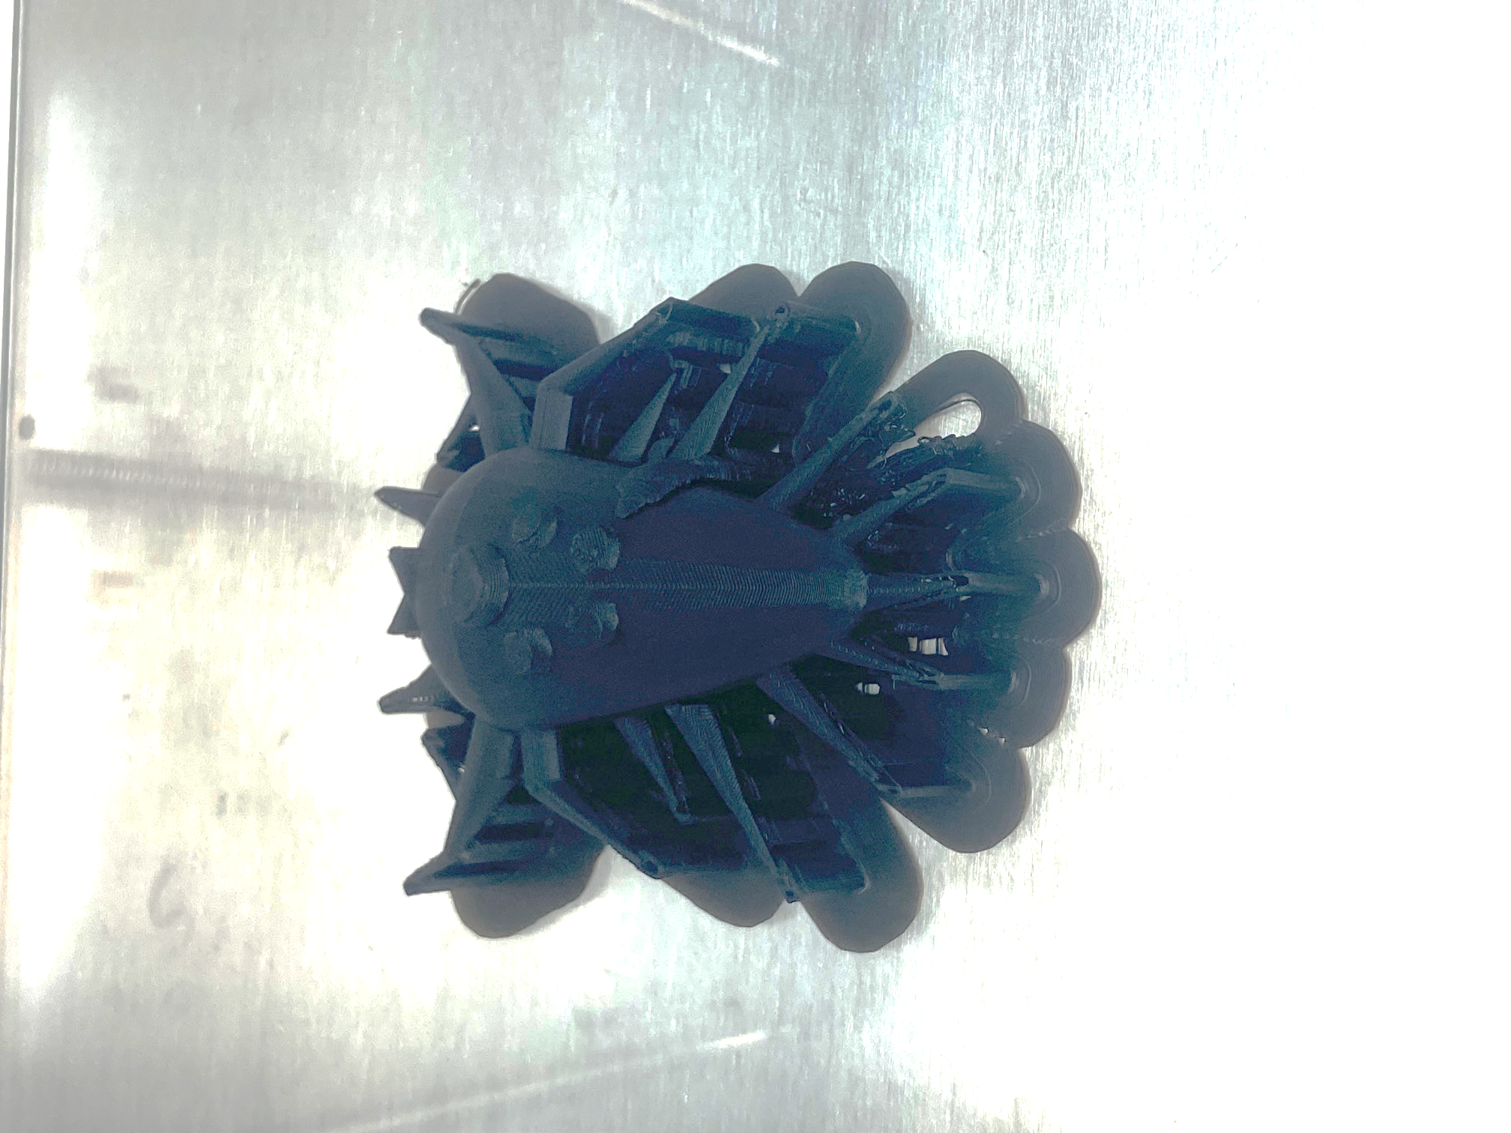

Step-By-Step Procedures:

1. Start the lesson by asking the students to define terms related to Three- Dimensional Printing.

* Three-Dimensional Printing – Additive Manufacturing- Turns 3D models into solid objects by building them up in layers.
* Slices – 3D printers construct the form by layering thing ‘slices’ of filament to make the form.
* Filament – a semi-liquid material (typically a bendable plastic) that can be molded into permanent forms.
* Material Extrusion – the nozzle of a printer pushes out a semi-liquid material into whatever shape the computer has instructed it to make.

1. Parts of a 3D printer.

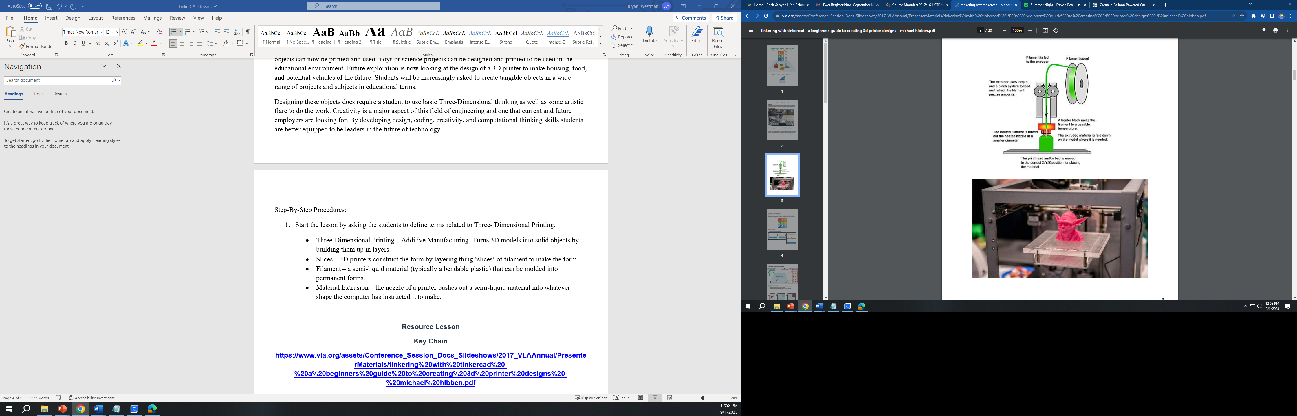

1. Students will watch an instruction video on the basics of Tinker CAD.

<https://youtu.be/gOs6Mdj7y_4?feature=shared>

This video shows the basic tools and how students can create shapes. Combine shapes, use line tools and erasers. There is information on how to share the file or print it.

1. Beginning the 3D process with a baggage tag. Each student will be given a printout of the baggage tag instructions so that they may follow along at their own pace. The instructions explain step by step how to use the basic features of the Tinker Cad Program. Once the program is made students should share the program or export it as a STL. file format.

**Lesson Resource’s**

**Basic Tinker CAD**

[**https://youtu.be/gOs6Mdj7y_4?feature=shared**](https://youtu.be/gOs6Mdj7y_4?feature=shared)

**Baggage tag.**

[**https://www.vla.org/assets/Conference_Session_Docs_Slideshows/2017_VLAAnnual/PresenterMaterials/tinkering%20with%20tinkercad%20-%20a%20beginners%20guide%20to%20creating%203d%20printer%20designs%20-%20michael%20hibben.pdf**](https://www.vla.org/assets/Conference_Session_Docs_Slideshows/2017_VLAAnnual/PresenterMaterials/tinkering%20with%20tinkercad%20-%20a%20beginners%20guide%20to%20creating%203d%20printer%20designs%20-%20michael%20hibben.pdf)

**Balloon Car**

[**https://www.tinkercad.com/projects/Create-a-Balloon-Powered-Car**](https://www.tinkercad.com/projects/Create-a-Balloon-Powered-Car)

1. Once the class has mastered a basic 3D object build, they will begin making a far more complicated program. The next design is a balloon car. This design will require multiple steps and accuracy will make a difference. Have the students follow the packet Balloon Car. If any step is skipped or alignment is off, then the car will not work. Using multiple principles of engineering the balloon car demonstrates, torque, potential energy, kinetic energy, and elastic energy. Students will demonstrate their final project with a contest to see whose car goes the furthest.

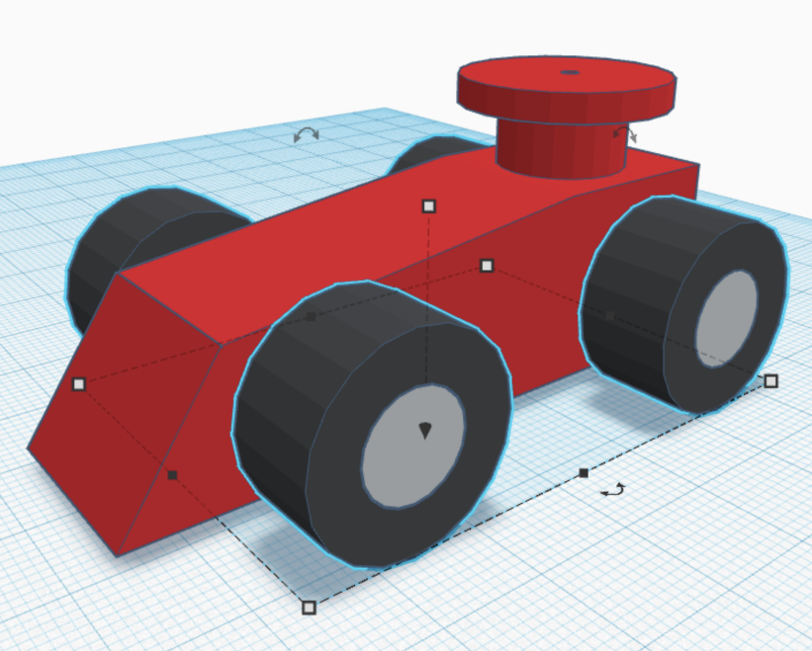

1. Rubric. A one-point rubric will be used to evaluate the work. Students will self-assess their effort and give themselves credit for the work that was done. They may reflect on any work that was not finished or of low quality. Any work that exceeded expectations should be documented and clearly explained as what the success was. Once this is done for the final grade students will participate in a portfolio review and will discuss with the teacher the good, the missed, and what they would improve on. A final grade will then be given.

Summary / Closure:

The use of 3D printing is becoming on of the fastest growing markets in the 21st century. Fields like biomedical, and aerospace engineering are looking to this technology for numerous uses that may not even exist yet. Students should look at this field as one of great potential. Then need to be accurate while being creative is an important aspect of this lesson. Once finished students should be able to use other programs and develop greater projects.

Evaluation: Assessment Based on Objectives:

The final grade will be based on the evaluation of the video piece, participation, effort, and quality of the work.

* Students will earn a percentage for their Portfolio Review, both as presenter and as audience.
* Quality of the work done will be a large part of the grade based on how well they have demonstrated an understanding of the concepts and their depiction. The overall quality of the final builds will also be a factor in the grading.
* Effort put into the project will be demonstrated by both the final video and how well the student worked in class on each project. (Factors include: Is the project completed, and does it look like the student worked on it and no other things?)
* The Rubrics are made up of 5 categories: Project completion (30%), Participation (20%), Originality (20%), Quality of design (20%), and Following directions (10 %).

Additional Components that can be included:

Plan for independent practice:

Students who are at a higher level or who have class on a greater number of days will also be given the added task of creating a car design using an alternative method of propulsion.

Adaptations: (For students with learning disabilities):

Those students with physical disabilities will be asked to either participate in group explorations or design a simple product that requires fewer moving parts.

Extensions (For gifted students): Students who complete the assignment early will be given the added assignment of developing a device that has real-world features that can be used for the benefit of the class or school.